1. Factory method is

* A static method calling a class constructor in a certain way
* A function/method/class that creates and initializes data
* One of the creational design patterns
* All of the above

1. Which Design Pattern should you use?

*When an object should be able to notify other objects without making assumptions about who these objects are. In other words, you don’t want these objects tightly coupled.*

* Chain of responsibility
* Decorator
* Observer
* State

1. What pattern is displayed on following diagram?

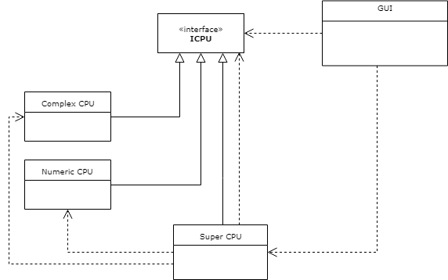

* Abstract Factory
* Visitor
* Strategy
* Composite

1. Based on the following GoF Definition identify the appropriate Design Pattern

*This pattern “defines an interface for creating an object, but let subclasses decide which class to instantiate. It lets a class defer instantiation to subclasses”*

* Abstract Factory
* Builder
* Decorator
* Factory Method

1. Is the following UML Diagram a valid representation of the Factory Method Design Pattern?

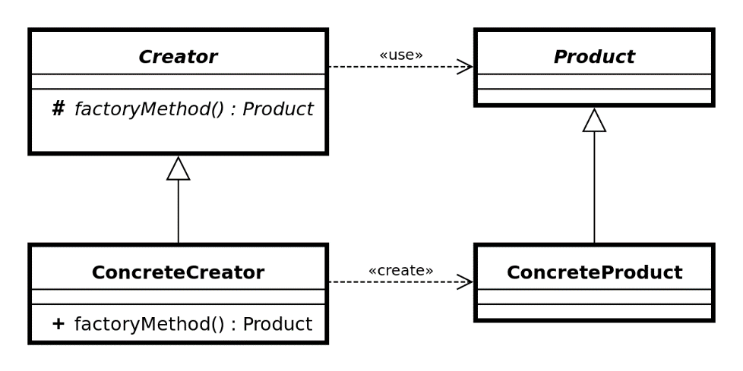

* No, the Creator class is too simple
* No, factoryMethod should always be public
* No, Product/ConcreteProduct is an overkill
* Yes, it is

1. Name the actor classes used in Memento pattern.

* Memento, Originator, CareTaker
* Originator, CareTaker
* Context, State, ConcreteState
* Abstraction, RefinedAbstraction, Implementor, ConcreteImpl